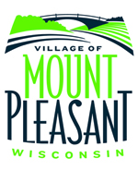
Village of Mount Pleasant
2019 BUDGET WORKSHOP AGENDA
Thursday, October 4, 2018 | 4:00 PM
Village Hall – Ebe Auditorium
8811 Campus Drive

4:00 PM

Village Board Budget Work Meeting regarding - 2019 Village Budget

Request for persons with disabilities who need assistance to participate in this meeting or hearing should be made to the Village Administrator or Clerk’s Office (262) 664-7800 with as much advance notice as possible. The Village Board will be present, but no formal actions will be taken.

Posted on September 27, 2018 at 1:30 pm

